" Building Partnerships for Services, Growth and Revitalization "

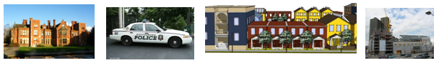

South Central Pennsylvania
Regional Summit
September 24, 2019
Doubletree Resort Lancaster, Pa

Presented by
The South Central Assembly

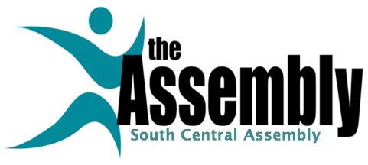
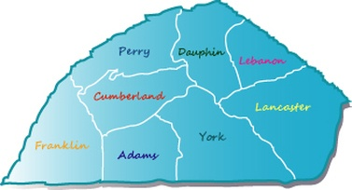

Regional Summit Introduction
"Building Partnerships for Services, Growth and Revitalization "

Dear Friend,
The South Central Assembly is pleased to invite you to our 2019 Regional Summit, "Building Partnerships for Services, Growth and Revitalization." This Summit provides a forum to share Best Practices and discuss key problems and issues facing communities, citizens and nonprofit agencies in Adams, Cumberland, Dauphin, Franklin, Lancaster, Lebanon, Perry, and York Counties.
Officials and professionals from state, local and county government, nonprofit and community planning organizations, banks, colleges, consulting firms, and interested citizens have been invited to the Summit, providing a chance for input from all sectors of South Central Pennsylvania.
The Summit features sessions in four tracks that offer a broad range of topics for groups that serve our communities. The tracks include: Local Government Innovation and Cooperation; Housing & Community Development, Coping with Regional Issues, and Workforce Development.
The Summit has been planned by volunteers from the South Central Assembly and its Regional Issues Committees. This biennial event is made possible by the generous support of the sponsors and exhibitors listed in this program. Additional Speakers and Panelists are still being added to our agenda, and will appear in later mailings.
We have built the Summit with you in mind, offering many sessions, a chance to hear your needs, and providing information on new resources and best practices to help you solve your community's problems. We have kept registration fees low and the value high to encourage attendance from all corners of the region.
Please forward this brochure to others who will find it useful.
We look forward to seeing you at the Summit!
Joan Brodhead, President

South Central Assembly

Summit Schedule
7:30 Registration / Continental Breakfast
Visit Exhibits
8:30 Welcome
Joan Brodhead, President, South Central Assembly
Lancaster County Commissioners Dennis Stuckey and Craig Lehman

"Interactive Regional Priority Setting" Jessica Trimble. Pa Dept. of Community & Economic Development

9:00 Morning Plenary Session
"Building Partnerships for Services, Growth and Revitalization"
Panel of Municipal, County and Non Profit Agency Officials

10:00 First Round Panel Sessions
11:00 Break / Visit Exhibitors
11:15 Second Round Panel Sessions
12:15 Luncheon Plenary Session
"Preparing For Census 2020 / Impacts On Your Community & The Region"
Panel of Federal, State, Local and PSU Officials

South Central Assembly Annual Regional Citizen Award
Presenter Scott Lamar, WITF
Awardee Douglas Hill, County Commissioners Assn. of Pa.

2:00 Third Round Panel Sessions
3:00 Break / Visit Exhibitors
3:15 Afternoon Plenary Session
"Building College and Community Partnerships For Growth & Revitalization" Panel of Area College Presidents & Community Officials
4:15 Summit Wrap Up - "Interactive Regional Priority Setting" Jessica Trimble
4:30 Wine & Cheese Reception

Dr. Beverly Cigler, Penn State University, Moderator
The Honorable Kevin Schreiber, State Representative
The Honorable Brenda Benner, Perry County Cmr.
. The Honorable Eric Papenfuse, Mayor of Harrisburg
The Honorable Terry Kauffman, West Lampeter Twp

3:45 Moving Ahead / Summit Findings
Steve Snell, SCA Vice President
4:00 Wine and Cheese Reception

Cost
Includes Materials, Breakfast, Lunch, Presentations, Refreshments
Registration is limited
$50 per person

Register On Line At
https://www.eventbrite.com/e/south-central-pennsylvania-regional-summit-tickets-69152060675
Who Should Attend?
- County & Local Officials
- Nonprofit & For Profit Agencies
- Human Service Agencies
- Planners
- Business Persons
- College & University Staff
- Realtors & Bankers
- Consultants
- Regional Agency Officials
- Community Leaders
- Interested Citizens

- "Interactive Regional Priority Setting" Part 1
8:30 Welcome - Joan Brodhead, SCA & Lancaster County Commissioners

- Live digital voting on regional priorities and organizational needs via audience cell phones
  - Jessica Trimble, Pa. Dept. of Community & Economic Development
"Building Partnerships for Services, Growth and Revitalization"
Morning Plenary Session 9:00
Affordable & Workforce Housing Challenges & Opportunities

- Experienced county, municipal, and nonprofit officials from across the region discuss how partnerships for services, growth and revitalization can be successfully developed among and between sectors and sustained for community and regional benefit.
- Moderator, George Klaus, South Central Assembly
- Tim Scott, Mayor, Borough of Carlisle
- Jo Ellen Litz, Commissioner, Lebanon County
- Kirk Stoner, Cumberland Co. County Planning Director
- Jennifer Wintermyer, Executive Director, Tri County Community Action Commission
- Mike Ross, Executive Director, Franklin Co. Economic Development Corporation

10:00 Panel Sessions

- Local Government Innovation and Cooperation -
- "Tools for Reaching Our Regional Water Quality Goals"
- Panelists will discuss potential methods and tools for taking a regional approach to water quality improvement. Session includes an EPA demonstration of their new “Chesapeake Bay Watershed Data Dashboard” for local scale planning and restoration efforts. Storm water management and green infrastructure are discussed.
  - Moderator, Ruth Ayn Hocker, P.E., CFM, D.WRE, Stormwater Program Manager, City of Lancaster
  - The Honorable Leo Lutz, Mayor, Columbia Borough
  - Dr. Emily Trentacoste, Ph.D., Environmental Scientist, US Environmental Protection Agency
  - Dr. Shirley E. Clark, Ph.D., P.E., D.WRE, F. EWRI, Professor of Environmental Engineering, Penn State University

- Housing, and Community Development -
- "Finding the Money: Increasing Financing for Affordable Housing - Going Beyond Low Income Housing Tax Credits"
- This Panel presents information on financing that is available to produce affordable housing without relying upon the 9% Low Income Housing Tax Credit Program.
  - Moderator: Jim Shultz, Housing and Community Development Consultant
  - David Doray, Manager of Multifamily Underwriting, PHFA
  - Claude Hicks, Director of Real Estate Development, Housing Development Corp., Mid-Atlantic
  - David Nikoloff, Vice President for Real Estate Lending, Community First Fund
  - Miriam Soto, Director of Lending, Lancaster Housing Opportunity Partnership

- Coping with Regional Issues -
- "College - Community Partnerships for Sustainable Growth"
- Municipalities are facing unprecedented pressure to address environmental concerns with limited resources. With expert knowledge and student / faculty resources, partnerships with local colleges and universities are helping to improve environmental conditions and promote sustainable planning. Panelists will explore how mutually beneficial partnerships between community leaders and university students, faculty, and staff create an effective environment for exchanging knowledge, expertise, and resources.
  - Moderator, Dr. Victor DeSantis, Interim Chief of Staff, Millersville University
  - Mr. Chris Steuer, Sustainability Director, Millersville University
  - Sustainability Director from Franklin and Marshall College (inv.)
  - Mr. Douglas Smith, Senior Planner, City of Lancaster

- Workforce Development -
- "Future of Work"
- 65% of jobs in the past 15 years no longer are in existence; rapid disruption in almost every industry; both the way and where we work will change; rapid growth in STEM occupations; the need to source, train and retain talent will need to be more adaptive in the next 10 years.
  - Moderator: Lauren Holubec, Harrisburg Area Community College
  - Tom Palisin, Executive Director, Manufacturers’ Association
  - Amanda Smith Jolene, Executive Director, ENGINE of Central PA
  - Sue Mukherjee, Chief Strategy Officer, Shippensburg University

11:15 Panel Sessions

- Local Government Innovation and Cooperation -
- "Implementing Opportunity Zones"
- This session provides an overview of the new Federal Opportunity Zone program including latest developments with the program’s regulations. The panel will also provide strategies on how the program is being implemented in several municipalities in the region.
  - Moderator, Fred Reddig, South Central Assembly
  - Evan Weiss, Governor's Senior Advisor for Public Finance, New Jersey
  - Jeremy Young, Community and Economic Development Manager, Lancaster City Alliance
  - Blanda Nace, Executive Director, Redevelopment Authority of the City of York

- Housing, Economic and Community Development -
- "Senior Housing Challenges"
- Session focuses on affordable housing challenges for seniors as well as employees who provide primary care. We will discuss both Institutions as well as Aging in Place. Two pilot projects of the PA Department of Aging - a shared housing model and portable housing cottages that share a property with family - will be presented.
  - Moderator, Steve Snell, South Central Assembly
  - Richard Jackson, Board Chair, Moravian Manor
  - David Swartley, President/CEO Moravian Manor
  - Julie Seby, Chief Housing & Community Services, PA Dept of Aging
  - Julie Fenton, Director of Business Development, Clearfield County Area Agency on Aging

- Coping with Regional Issues -
- "Resources For Growth, Revitalization, and Municipal Administration"
- This session provides information on several helpful programs and services for municipalities, businesses, banks, and nonprofit housing and community development agencies. Overview presentations on FHLB's Affordable Housing Program; USDA RD's infrastructure, business development, housing, and community facilities programs, and Benecon's health insurance cooperatives / consortiums for municipalities, counties, colleges, school districts, banks, and retirement homes will be offered.
  - Moderator, Joan Brodhead, Community First Fund
  - Fred Banuelos, Community Investment Business Development Manager, Federal Home Loan Bank
  - Dave Corwin, Housing Programs Director, USDA Rural Development
  - Fred Bean, Vice President, Program Management, Benecon

- Workforce Development -
- "Work Based Learning & Summer Jobs 2020"
- SCPa Works will be launching and coordinating a regional effort to create the largest summer jobs program in the Commonwealth; business leaders, training providers, community-based organizations, etc. will gather to discuss the importance of work-based learning for all of our region's youth. Research shows effective summer jobs programs for youth is one of the best investments to make for long-term success in the labor market.
  - Moderator: Ellie Lamison, Central York School District
  - Mike Barba - Director of Programs, SCPa Works
  - Doran Condon - Program Associate, SCPa Works

Luncheon Plenary Session 12:15

- Welcome, Sponsor Recognition - Joan Brodhead, President, South Central Assembly
- Presentation of Annual South Central Assembly Regional Citizen Award by Scott Lamar, WITF to Douglas Hill, Executive Director, County Commissioners Association of Pennsylvania
- Luncheon Plenary Session
- "Preparing For Census 2020 / Impacts On Your Community & The Region"
- Federal and State representatives will provide the latest on planning for the 2020 Census and offer ways that municipalities, community and non-profit agencies can assist in achieving a complete and accurate count, which can increase a community's share of available federal funding.
  - Fred Reddig, South Central Assembly
  - Fernando Armstrong, Regional Director, US Census
  - Norman Bristol Colon, DCED 2020 Complete Count Executive Director
  - Beth Shultz, State Data Center, Penn State University
2:00 Panel Sessions

- Local Government Innovation and Cooperation -
- "Updating and Implementing Comprehensive Plans"
- Discussion of best practices to achieve implementable, action-oriented, cost-effective comprehensive plans or plan updates at county and municipal levels.
  - Moderator: Jessica Trimble, MPA, Local Government Policy Specialist, DCED Governor's Center for Local Government Services
  - Felicia Dell, AICP, Director, York County Planning Commission
  - Scott Standish, Director for Countywide Planning, Lancaster County Planning Commission
  - Betsy Logan, AICP, Director of Community & Economic Development., Susquehanna Twp,
  - Dan Zimmerman, Manager, Warwick Twp.

- Housing and Community Development -
- "Housing Rehab and Neighborhood Revitalization - Improving Existing Housing & Neighborhoods "
- Successful, systematic Housing Rehabilitation can be a core component of neighborhood and community revitalization in our Cities and Boroughs. Our panelists discuss how to create and sustain effective housing rehab programs for neighborhood revitalization.
  - Moderator: Ed Geiger, Principal, Edge Strategic Consulting
  - Chris Gulotta, Principal, The Gulotta Group
  - Michaela Allwine, Housing Manager, Lancaster County Housing & Redevelopment Authorities
  - Carlos Graupera, SACA inv.
  - Eileen Divringi, Community Development Research Associate, Federal Reserve Bank of Philadelphia

- Coping with Regional Issues -
- "Rebuilding Infrastructure - Roads & Bridges"
- An update on transportation planning and funding in the south central region including a discussion of Act 89’s Comprehensive Transportation Funding Plan. The session will also address Cumberland County’s innovative approach to address its deteriorated bridges thru its Bridge Capital Improvement Program.
  - Moderator, Steve Nevada, Assistant County Administrator, Franklin County
  - Mike Keiser, District Executive for PennDOT District 8-0
  - Barry Schoch, KCI Technologies, former PennDOT Secretary
  - Kirk Stoner, Planning Director, Cumberland County

- Workforce Development -
- "Career Pathways"
- Opportunity occupations are jobs accessible to workers without a bachelor's degree and typically pay above the annual median wage. Recent research from the Federal Reserve Bank of Philadelphia found that metro areas in South Central Pennsylvania have above-average rates of opportunity employment. This panel discusses best practices for collaboration between educational institutions, the private sector, nonprofits, and government entities to develop career pathways for opportunity employment, including training and job placement, in South Central Pennsylvania.
  - Moderator: Alison Shott, Community Engagement Associate,-Federal Reserve Bank of Philadelphia
  - Victor Rodgers, Associate Provost for Workforce Development, Harrisburg Area Community College
  - Jodi Pace ??
  - Keith Wardrip, Community Development Research Manager, Federal Reserve Bank of Philadelphia

"Building College and Community Partnerships For Growth & Revitalization"
Afternoon Plenary Session 3:15

- College Presidents discuss how to create and sustain successful College - Community Partnerships for Growth and Revitalization.
  - Moderator, Harrison Bink, Bink Architects
  - Dr. John Sigielski, President, Harrisburg Area Community College
  - Dr. Barbara Altmann, President, Franklin and Marshall College
  - Millersburg State University President ( invited)

Summit Wrap Up 4:15

- "Interactive Regional Priority Setting" - Results Part 2
  - Joan Brodhead, SCA and Jessica Trimble, Pa Dept. of Community & Economic Development

Wine & Cheese Networking Reception 4:30

Summit Planning Committee
Susan Armstrong, Carlisle Borough
Harrison Bink, Bink Architects
Joan Brodhead, Community First Fund
Dr. Beverly Cigler, PSU, Emerita
Darren Burroughs, Harrisburg Housing Authority
Ray D'Agostino, Lancaster Housing Opportunity Partnership
Dominic DelliCarpini, York College
Shireen Farr, CAEDC
Ed Geiger, EDGE Consulting
George Klaus, York Housing Coalition
Fred Reddig, Local Government Consultant
Steve Snell, York Housing Coalition
Alison Shott, Federal Reserve Bank of Philadelphia
Jim Shultz, Housing & Community Development Consultant
Jessica Trimble, Pa DCED
Samantha Vollrath, SDHP
Tim Whelan, Cumberland Co. Housing & Redevelopment Auth.

Summit PowerPoint's and Handouts will be available on SCA's website at http://www.southcentralassembly.org/ in November, 2019.

The South Central Assembly is a 501(c)3 nonprofit corporation which helps public and private sector
organizations work together to enhance the quality of life for the communities and citizens of South
Central Pennsylvania. The Assembly works through four Policy Issue Committees composed of SCA
Board members and interested volunteers to fulfill its mission. The Committees are Local Government
Innovation and Cooperation, Housing & Community Development, Regional Connections
and Higher Education and the Community. For further information or to join the Assembly or its
Committees, visit at www.southcentralassembly.org or contact SCA President Joan Brodhead at jbrodhead@communityfirstfund.org

The Mission of the South Central Assembly is to encourage collaboration, cooperation, and development of regional solutions, and the sharing of best practices between communities within the eight counties of South Central Pennsylvania.

Register online when paying by credit card at
https://www.eventbrite.com/e/south-central-pennsylvania-regional-summit-tickets-69152060675

SUMMIT REGISTRATION FORMFORM
Doubletree Resort
2400 Willow St. Pike
Lancaster, Pa 17602
Hotel Phone 717 464 2711
Google Doubletree Resort Lancaster for Directions

Please use a separate registration form for each participant if paying by check
Please print clearly
(first name) __________________ (mi) ______ (last name) _________________________________
Agency/ Organization/ Municipality ___________________________________________
Title __________________________________ County _____________________
Address _________________________________________________________________
City _____________________ State __________________ Zip __________
Daytime Phone _________________ Fax _________________________________
Email _________________________________________________________________
Summit Participant Directory - Please list my contact information Yes ___ No ______
Special Dietary Requirements __________________________________________
ADA Special Needs _______________________________________________________

Please mark tracks you plan to attend:
Local Government ____ Housing & CD ____ Regional Issues ____ College & Community ____

Summit Fee $50

For Credit Card Payment Register On Line at
https://www.eventbrite.com/e/south-central-pennsylvania-regional-summit-tickets-69152060675
To Pay By Check -
Make checks payable to South Central Assembly / mail with registration form(s) to:
South Central Assembly
PO Box 865
Carlisle PA 17013
Please Forward This Brochure to Friends & Colleagues Who May Be Interested

Thanks To Our Sponsors For Making This Event Possible
Partners
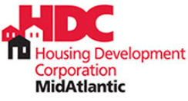

Federal Partners
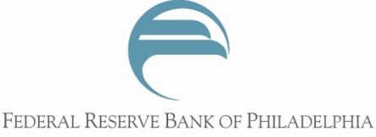

Sponsors
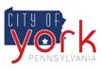
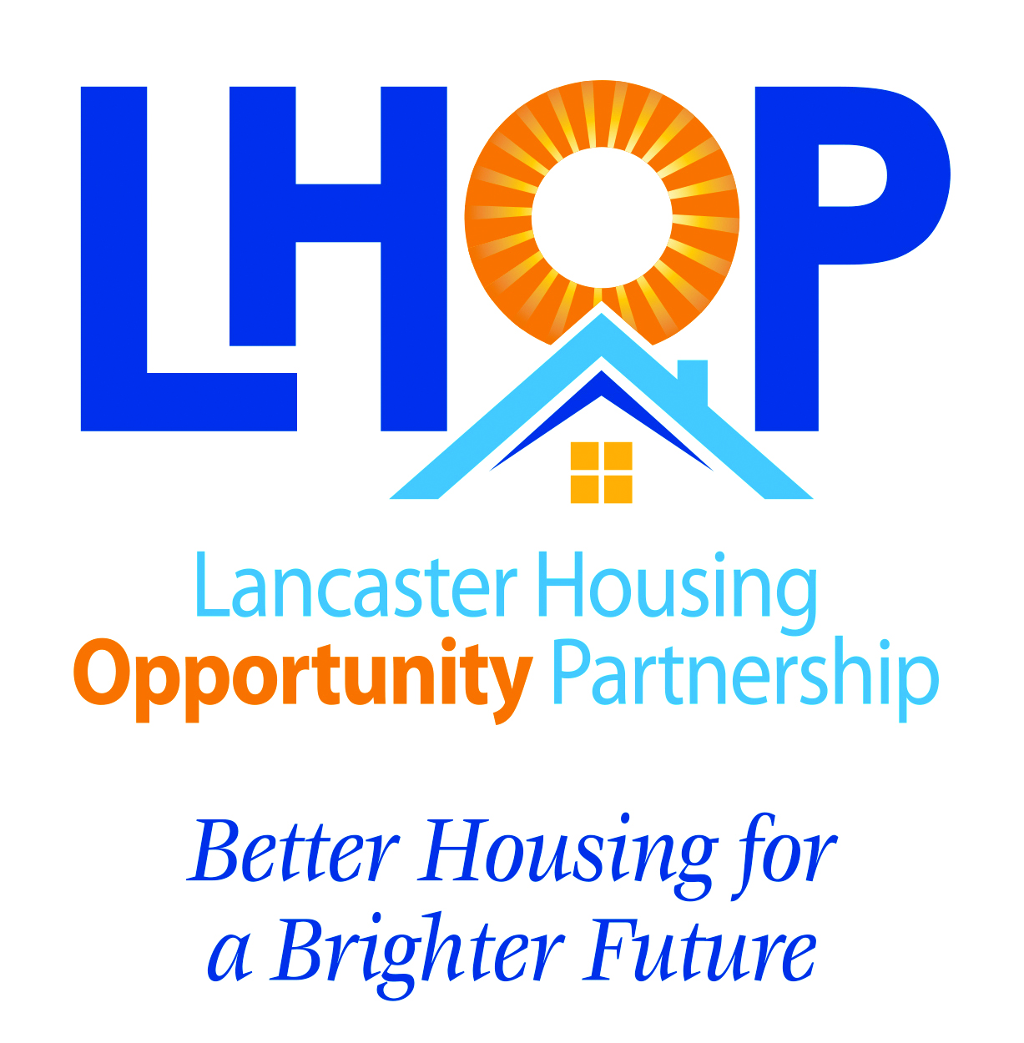
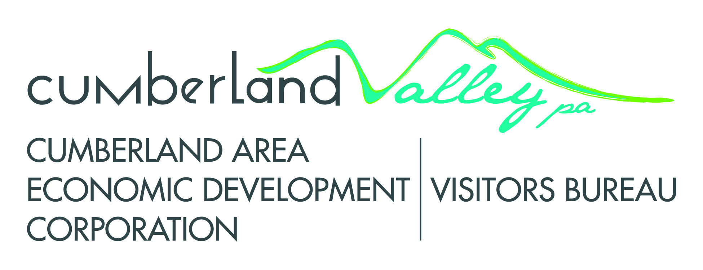

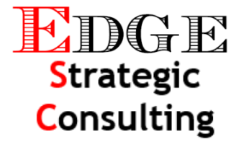

Special Thanks For Marketing Assistance
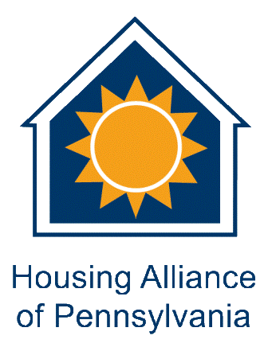
Additional Sponsors Gladly Welcomed

